**Master Functional Document**

|  |  |
| --- | --- |
| **Application** | NGERP - Centra |
| **Service Bundle** | Master Management |
| **Service Request** | Expense Type |

**Description:**

In Compiere (NGERP - Centra), Expense Type define how expenses are categorized, managed, and processed within the system. They help in tracking purchases, invoicing, and managing financial transactions by specifying rules for pricing, taxation, inventory, and accounting, enabling effective financial tracking and reporting.

**Workflow Process:**

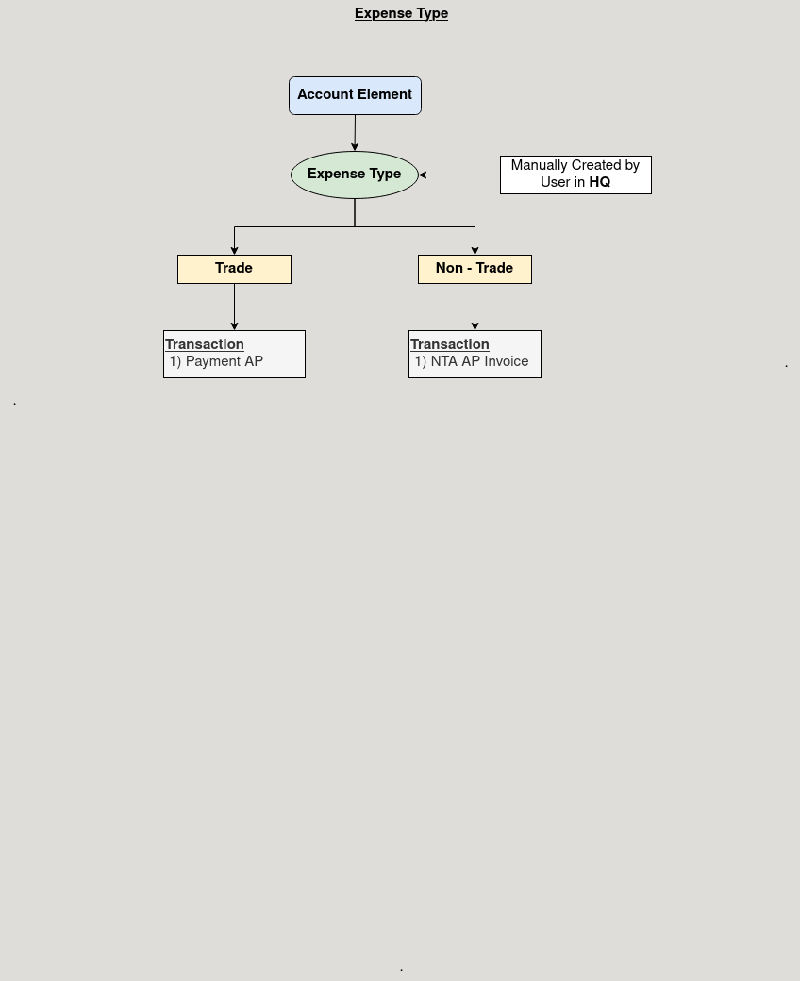

**Business Rules:**

* It is visbile only in **HQ.**
* **Creation** is also possible in **HQ.**
* Expense typemust be linked to a specific companyandbranch for proper record-keeping.
* Product categories and tax categories should be defined for each expense type to ensure accurate reporting.
* Accounting rules must be established for each expense type to accurately track costs, revenues, and variances.